Name: _________________________________________ Date: ____________________
Prime Factorization
6 NS 4: I will find the greatest common factor of two whole numbers less than or equal to 100 and the least common multiple of two whole numbers less than or equal to 12. Use the distributive property to express a sum of two whole numbers 1–100 with a common factor as a multiple of a sum of two whole numbers with no common factor.

How does breaking down parts help you to problem solve? _____________________________________________________________________________________________________________________________________________________________________________________________________________________

WARM-UP
Tell Whether the Number is  Prime or Composite.  5  _____________ | Tell Whether the Number is  Prime or Composite.  72  _____________ | Tell Whether the Number is  Prime or Composite.  1,024  _____________

VOCABULARY EXAMPLE
Factor: _________________________________________________________________________
_________________________________________________________________________
_________________________________________________________________________

Prime Factor:
________________________________________________________________________
_________________________________________________________________________

Write a composite number as a product of its prime factors (Prime Factorization) pages 16-17
Method 1 (table) | Method 2 (tree)
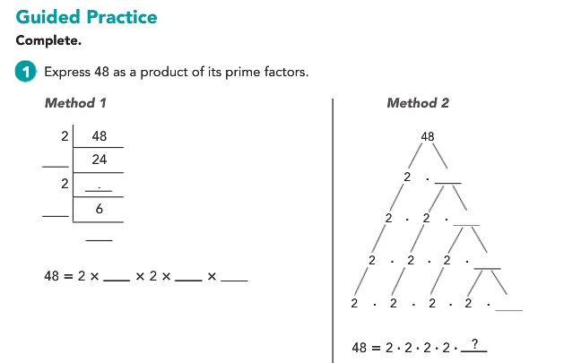
With a partner
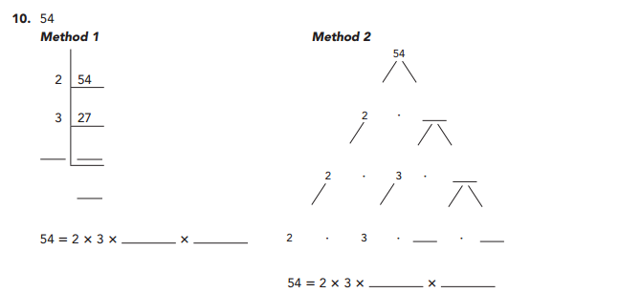

Method 1  18 | Method 2  24
Independent Work….You must show your work for full credit. Use a separate piece of paper if needed

Select 10 problems from page 18 to complete. Read the instructions for each problem selected. All work must be legible for credit.

# | #
# | #
# | #
# | #
# | #

